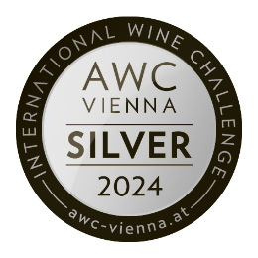

**2023 Riesling Niederberg Helden**

|  |  |
| --- | --- |
| Varietal | Riesling |
| Style | Halbtrocken |
| Wine Region | Mosel / Deutschland |
| Alcohol Percentage | 12,5 %-Vol. |
| Residual Sugar | 2,5 g/l |
| Acidity | 7,1 g/l |
| Fermentation | 100% Stainless Steel |
| Format | 750 ml |

The flagship of our winery is back after a one-year break and shimmers in the glass with a flawless light lemon yellow color.

A clear pineapple aroma with hints of citrus blossom unfolds on the nose, while on the palate this Riesling from the Niederberg Helden vineyard presents itself with opulent fruit notes, perfectly integrated minerality and a long, fresh, intensely fruity finish.

An elegant and typical Mosel Riesling that perfectly reflects its origin from the great Lieser vineyard.